Project Design Phase-II
Data Flow Diagram & User Stories

Date | 28-11-2025
Team ID
Project Name | Book Store
Maximum Marks | 4 Marks

Data Flow Diagrams:
A Data Flow Diagram (DFD) explains how customers interact with the Online Book Store system, how book order data flows, and where it gets stored.
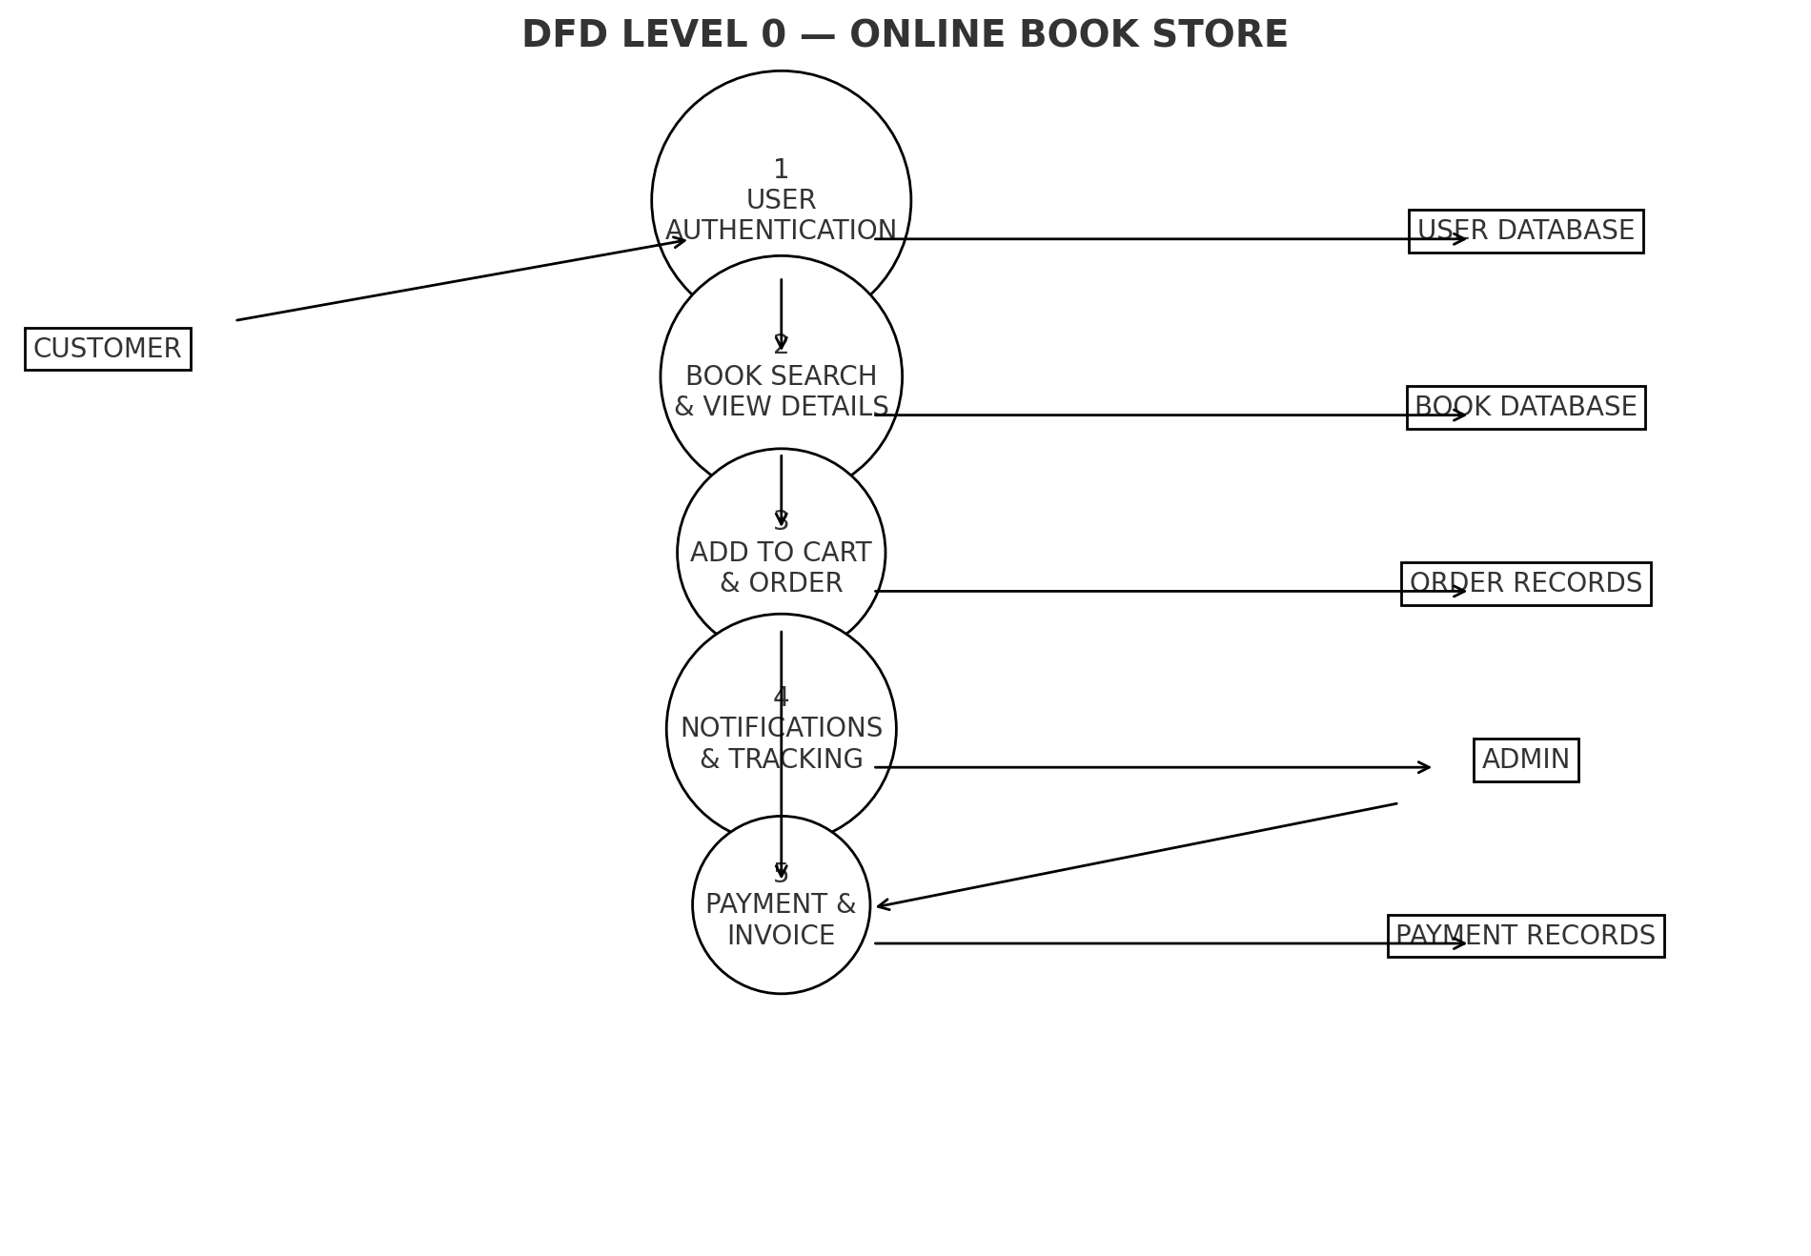

User Stories

User Story Table – Book a Doctor
User Type | Functional Requirement (Epic) | User Story / Task | Acceptance Criteria | Priority | Release
Customer | Book Search | As a user, I can search books by category, author, and title | Relevant books displayed | High | Sprint-1
Customer | Book Ordering | As a user, I can order books and view delivery updates | Order confirmation message shown | High | Sprint-1
Customer | Payment | As a user, I can pay online for my order | Payment success alert and invoice shown | Medium | Sprint-2
Customer | Notifications | As a user, I get updates on my order status (shipped/delivered) | Notification received via email/SMS. | Medium | Sprint-3
Admin | Book Management | As an admin, I can add, update or delete books | Book list updated successfully | High | Sprint-1
Admin | Order Approval | As an admin, I can process and update order status | Order status updated correctly | High | Sprint-2
user | Review | As a user, I can review purchased books | Reviews visible on book page | Medium | Sprint-3

